Use Case Realisation Report - Manage Project
FOR
Volunteer Management System
(VMS)

CLIENT
PROJECT | Volunteer Management System (VMS)
TITLE | Use Case Realisation Report - Manage ProjectUpdate profile
VERSION | 0.1a
DATE | 13-Aug-2011
 | ORIGINATOR
 | Name / Signature | Team 8S
 | APPROVAL
 | Name / Signature | Phung Kim Cuong, Dio
Institute of Systems Science |  | Document Reference
25 Heng Mui Keng Terrence  Singapore 119615 |  | VMS/PM-1.3.1/1

 | Acceptance
 | Customer Signature |  | Customer Signature
 | Name & Designation |  | Name & Designation
 | Date & Company Stamp |  | Date & Company Stamp

Revision History

Date | Version | Description | Author
12-Jun-2011 | 0.1a | Creation | Team 8S
 |  | Refer to amendment history

Table of Contents

1. Brief Description 3
2. Flow of Events 3
2.1 Standard Flow 3
2.2 Exceptions 3
3. Interaction Diagrams 3
3.1 Domain Collaboration Diagram: Update profile 3
4. Participating Objects 3
ANNEX D Amendment History 5

Use-Case Realization Report
Update Profile

Brief Description
The use case enables registerd User to update his/her profile.

Flow of Events
The standard flow of events for this use case and any exceptions are described in the following subsections. See section 3.1 for an overview of the participating Actors and Domain Objects.

Standard Flow

Precondition: User has logged in the system

This use case provides the user interface related functionality that will be provided to the User, as follows:
- When the User clicks ‘Update Profile’ link on the NAVMenu, the method NAVMenu.updateProfile() will be triggered and it will use MainController.redirectURL() method to redirect to UserProfileScreen.
- The use MainController.redirectURL() will use the UserProfileScreen.show() method to display a input form enabling the User to edit personal info
- UserProfileScreen.show() will fetch the user details by calling the method UserController .getUserDetails()
- The UserProfileScreen.show() method will use User.getUserFullName()/Nationality/DOB/Gender/LaunguageProficiency/Profession/Contact/Address to populate User detailed information on the screen
- The User can edit following info:
  - Full Name
  - Nationality
  - Date of Birth
  - Gender
  - Language Proficiency
  - Profession
  - Contact
  - Address
- When user click ‘Update’ button, The UserProfileScreen .OnSubmit() method will be triggered and it will use UserProfileScreen.validateFormat() method to perform basic format checking
- After checking is done, the UserProfileScreen will use the UserController .updateUserProfile() method to update the user info to data persistence.
- UserController.updateUserProfile() will use the UserProfileScreen.displayMsg() method o display a confirmation message to User.
- The use case terminates

Exceptions
The following exceptions have been identified:
- Invalid Information Format. If any of input info is incompatible, system will give a validation summary for user to make corrections

Interaction Diagrams

Domain Collaboration Diagram: Update profile
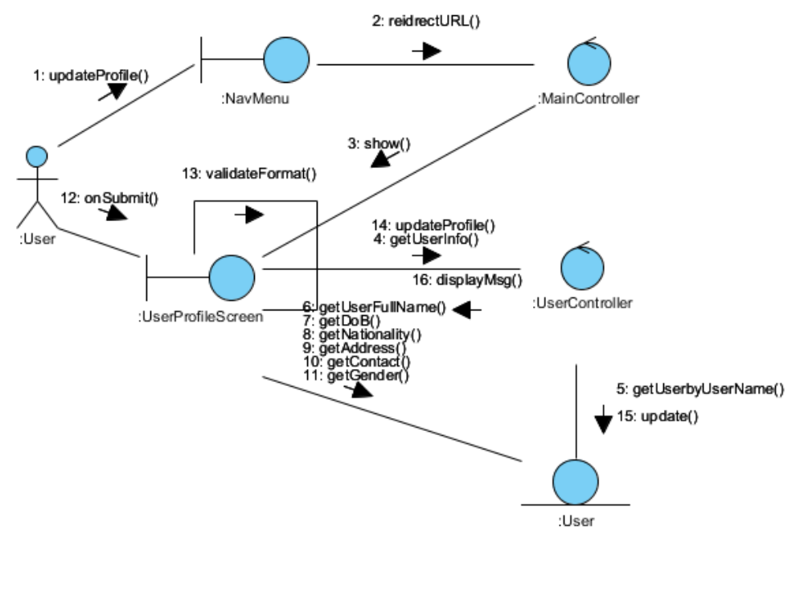

Participating Objects

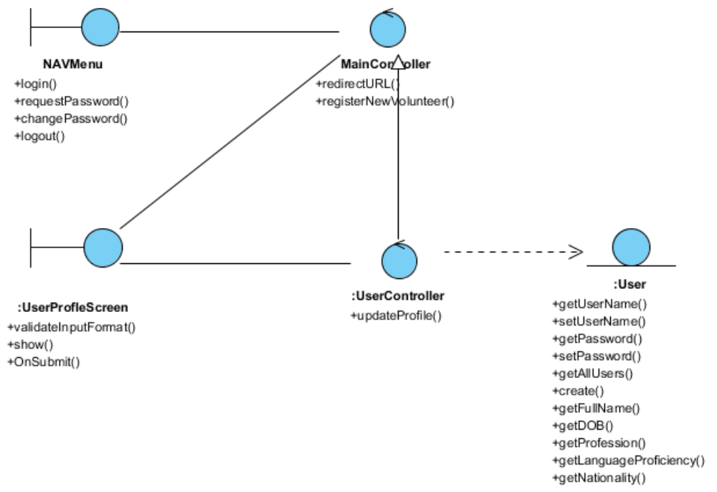

ANNEX D Amendment History

This is a record of all amendments made to the Document.
Version | Chapter / Section | Page No | Notes of Amendments or Changes

